Dunning Process

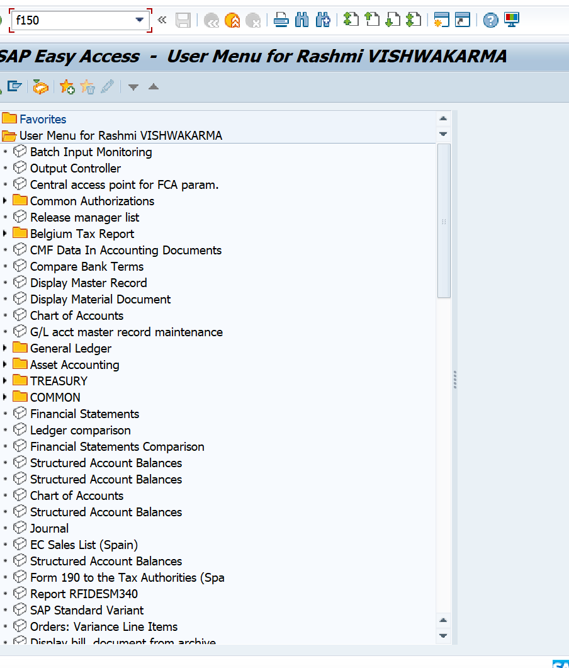
Press enter and we will get below screen
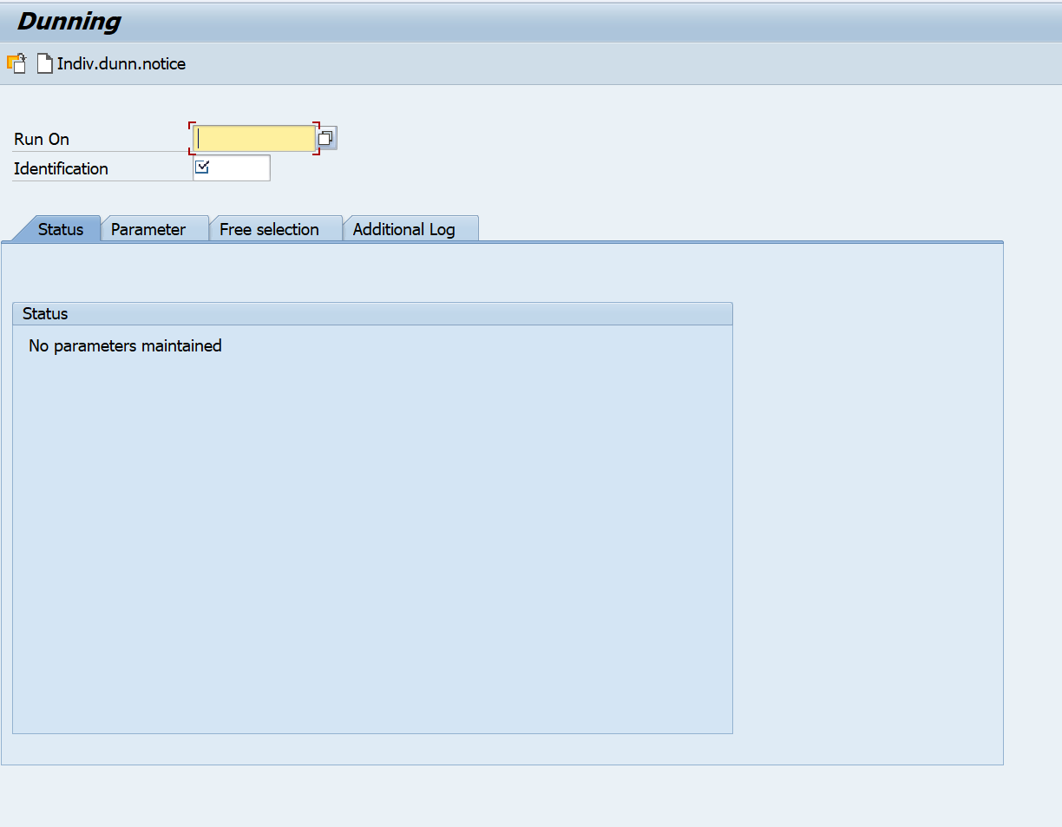
In Runon- always a current todays date
Identification- Fr01 (always)
Then come to the parameter, you will get this screen,
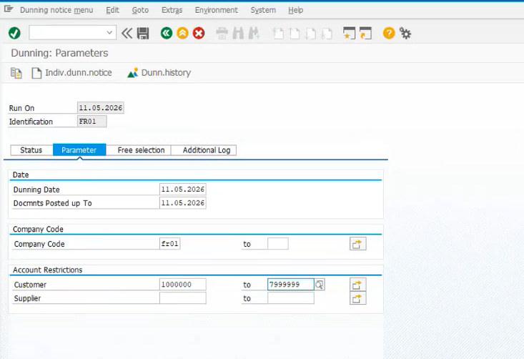
Duning date always current todays date
Document posted upto – always todays date
Company code - Fr01
Customer- 1000000 to 7999999 (always)
Then come to free selection you get-
